Project BELControl, Final Scientific Report

Nicolas Morel, LESO-PB/EPFL, Lausanne
Antoine Guillemin, Thomas Schumann, Adhoco, Winterthur

22 July 2008

1. Goal of the project

The project aims at the elaboration, the experimentation and the realization of a ready-to-use prototype of an advanced bio-mimetic controller for blinds and electric lighting. The control algorithm simultaneously optimizes the energy saving (through an optimal use of passive solar gains, other free heat gains and daylighting), while maximizing the indoor comfort and the acceptance by the user thanks to an adaptation of control parameters to user preferences.

The project does not start from scratch. It rather build on existing knowledge both at the LESO-PB/EPFL and at Adhoco. The principles of the control algorithms were developed in the research project AdControl carried out at LESO-PB/EPFL during years 2001 and 2002. They are explained in detail in a PhD thesis by Antoine Guillemin (Using genetic algorithms to take into account user wishes in an advanced building control system, thesis #2778, EPFL, 2003; the document can be downloaded from the web site http://library.epfl.ch/theses/?nr=2778). Therefore, we will not give here a detailed description, but only the principles.

The system which was tested experimentally in the framework of the project AdControl on the LESO Building (16 office rooms during 9 months, with a detailed measurements of conditions and user interactions in every room) was implemented as a research laboratory version. The main weak point was the reliability. Besides algorithm improvements and additions, one important goal of the BELControl project is the improvement of the reliability, in order to reach the status of a marketable final product.

Another characteristics of the commercial product available at the end of the project is the use of wireless connexions between the central control unit and the actuators and sensors. This is a key characteristics for an easy implementation by building practioners: it allows the installation with a very limited number of cables to install. The consequential issue of the power source used for the sensors has been solved (not in the framework of this project) by Adhoco by lowering the power use by the sensors, and offering two versions for each sensor (a clippable PV panel and a small battery which has to be changed once only for several years of use).

2. Control algorithms

2.1 Adaptation to user preferences

The control algorithms are based on the use of fuzzy logic to implement expert or common sense rules for the building services being controlled. The detail of the rule bases is not given here. An essential component is the adaptation to user preferences. It has been shown in the research project AdControl (see PhD thesis of Antoine Guillemin referenced above) that this aspect is very significant in improving the acceptance of the automatic control system. These results can be summarized by the table below (the acceptance is evaluated by the proportion of users who prefer the automatic controller to the manual controller, after a one-month measurement period):

Controller variant | Energy use compared to base case | Acceptance
Manual control (base case) | - | -
Smart control without adaptation to user preferences | - 25 % | 75 %
Smart control with adaptation to user preferences | - 25 % | 95 %

The adaptivity allows to keep the same energy saving due to a smart control algorithm, while reducing the rejection by users from 25 % down to 5 %.

The mechanism of user adaptation, in the present project, is the same as described in the PhD thesis of Antoine Guillemin. It is based on the use of Genetic Algorithms. A complete description is included in the PhD thesis mentioned.

2.2 Venetian blinds

The research project AdcControl carried out at LESO-PB only considered fabric blinds as implemented on the LESO Building. An addition to the existing algorithms was therefore needed for venetian blinds.

At the beginning of the project, two important points have been identified:

- Since every user has very different wishes concerning the venetian blind positioning, the adaptivity of the control is the key issue; in order to fulfill this requirement, Genetic Algorithms are used as discussed above.

- Nevertheless, the basic control of the venetian blind (before any user interaction and adaptation) needs to be well defined and chosen. The general guidelines for the basic control are to propose the most possible energy efficient control and trying to be user friendly at maximum.

The basic rules defined are summarized below:

When the user is absent (nobody in the room):
Energy efficiency control at maximum depending on season.

When the user is present:
- during night → privacy (blinds down, slats closed)
- during day with low illuminance → maximize daylight (blinds up)
- higher illuminance in winter → protect from glare and keep solar gains (blinds height position fuzzy controlled)
- higher illuminance in summer → protect from glare and reject solar gains (blinds down, slats fuzzy controlled)

Additional limitations coming from the indoor temperature are added as in the PhD thesis mentioned.

3. Simulation tests

3.1 Simulation models

3.1.1 Introduction

The structure and implementation of the Adhoco controller allows a direct connection with a simulation model, in such a way that a standard algorithm may be compared with the new Adhoco controller, and this for various heating systems. The simulation model is based on the use of Simulink/Matlab (we used version 7.1 of Matlab). A first version of the software has been elaborated in the framework of another research project, in which the LESO-PB, in collaboration with another project partner, was in charge of simulation tests (European research project EccoBuild). Several aspects needed complements for the BELControl project, especially:
- the need to consider not only convective heating but also water radiator heating and floor heating systems;
- the need to be able to easily compare heating system variants;
- the direct connection of the Adhoco controller to the simulation software.

Therefore, LESO-PB has elaborated new models for heating systems and heating controllers. These models are explained in the present report.

Some of the software blocks were developed using SIMBAD (SIMulator of Building And Devices) version 4, a Simulink add-on elaborated by the CSTB (Centre Scientifique et Technique du Bâtiment, France) and containing models of buildings (or building elements) and HVAC equipment.

In this report, we will only develop the thermal models. The description of the daylighting models, especially the ones for the sky luminances and the solar shadings, can be found in other documents, for instance the PhdD thesis of David Lindelöf (Bayesian Optimization of Visual Comfort, 6 June 2007, available from LESO-PB/EPFL).

3.1.2 Structure of the simulation software

The structure of the simulation software is illustrated by the diagrams below, showing both the complete diagram and an expansion of the heating model.

The component blocks have the following function:
- INPUT FILE: reading of the tabulated data
- SOLAR STRATEGY: position of the solar protections (fraction of occlusion and slat angle for a venetian blind)
- ARTIFICIAL LIGHT MODEL: fraction of electric lighting needed, in function of available daylight and occupancy
- DAYLIGHT MODEL: available daylight level and visual comfort
- HEATING MODEL: heating device and control
- COOLING MODEL: cooling device and control
- THERMAL MODEL: thermal model of the studied room or building, taking into account the various heat gains

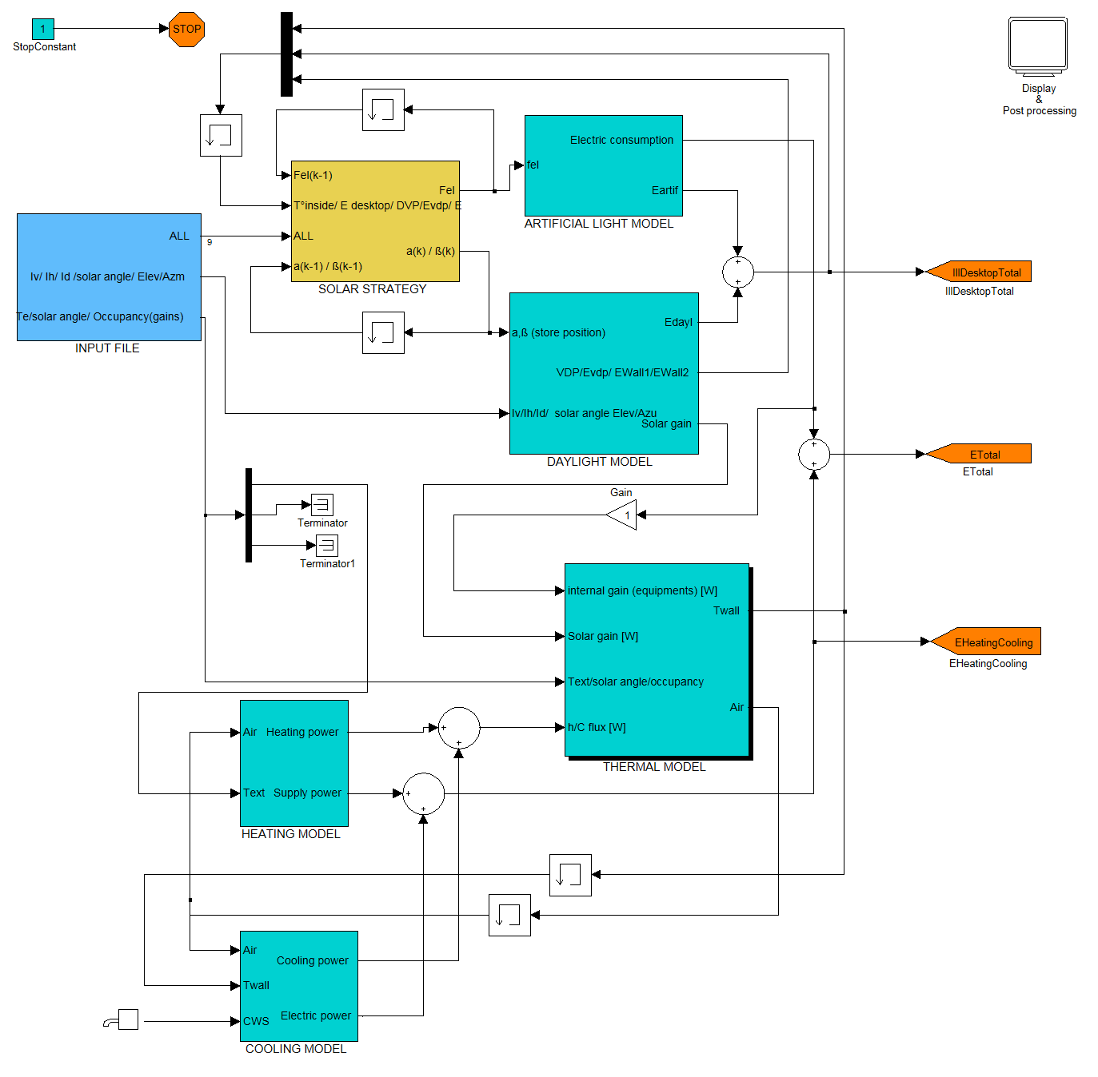

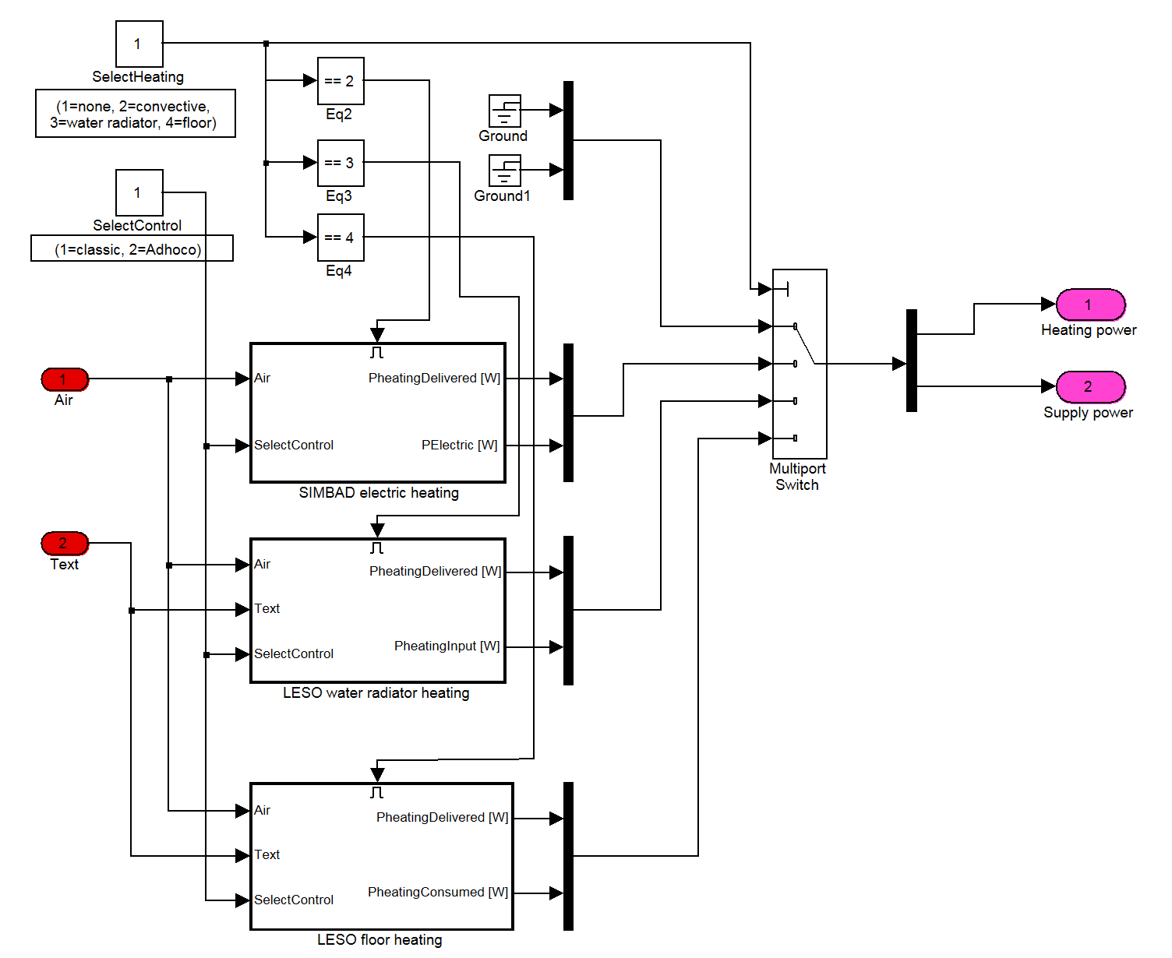

3.1.3 Thermal building model

The SIMBAD block library contains a collection of standard building types, thus avoiding the development of a detailed building model. The most simple of these standard buildings are generally built on a simple differential equation system, with two state variables (coarsely representing respectively the heaviest and lightest parts of the building). One of these models, valid for a residential one-family house, has been chosen. A variant allows also to consider an office building.

3.1.4 Heating system models

The SIMBAD block library includes simple electric direct heating (either light or heavy), a hot water radiator model, and a floor heating system based using either hot water or electricity. We have made some tests with these models: if the electric direct heating with a light thermal mass is a good model for a convective heating, the hot water radiator model presented some stability problems (the water flow is very critical: if too high or too low unstabilities arise), and the floor heating with hot water simply did not operate (we have not been able to correct the programming bugs, having a limited access to the model content).

We have therefore developed our own models for the three variants we wanted to compare.

Moreover, in order to be able to compare the Adhoco controller with standard commercially available controllers, models of the latters have been elaborated. The simulation software offers the choice between the Adhoco controller and a standard commercially available controller. For each heating system, a different controller, corresponding to the most common implementation, has been associated. Both the heating device and the associated controller are presented in the following sections.

A. Convective heating and simple hysteresis controller

A convective heating simply delivers the controlled heat power to the air node of the building. Therefore, the model is very simple, and can be represented by the diagram below. 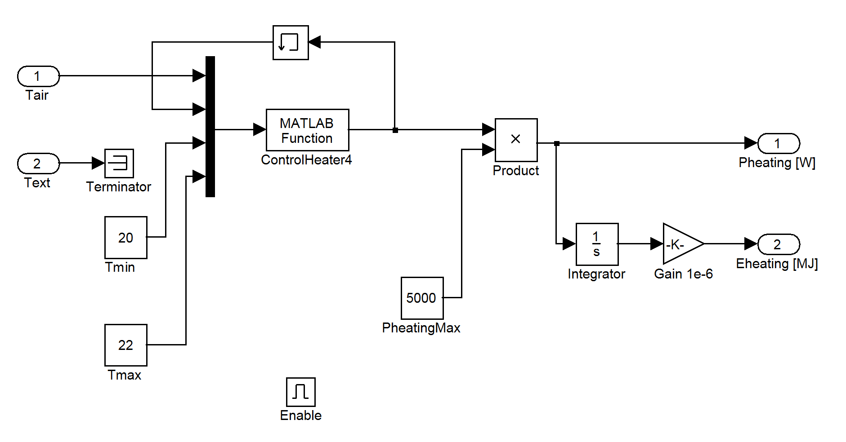
We have chosen to implement the hysteresis controller with a Matlab function block, but we could have used an hysteresis Simulink block instead. The Matlab function ControlHeater4 is very simple, but illustrates well the implementation of a block as a Matlab function. It is listed below.

% function y=ControlHeater4(u): simple hysteresis controller
% u(1)=air temperature [°C]
% u(2)=function output from last timestep
% u(3)=lower threshold temperature [°C]
% u(4)=upper threshold temperature [°C]

function y = ControlHeater4(u)

Tair=u(1,1);
yPreviousStep=u(2,1);
Tmin=u(3,1);
Tmax=u(4,1);

if(Tair<Tmin)
y=1;
elseif(Tmax)
y=0;
else
y=yPreviousStep;
end

B. Hot water radiator heating, controlled by a "heating curve" and a thermostatic valve

Physical model of the hot water radiator

The radiator is modelled as a series of segments, each segment having a hot water input with a given temperature, and a hot water output with another temperature. It is supposed that the input hot water is instantly completely mixed with the hot water alreaddy present in the segment, yielding a hot water temperature equal to T_{segment}, and that the heat loss to ambiant air (temperature T_{a}) is given by the equation

P = h (T_{segment} - T_{a})^{k}

where the exponent k is usually between 1.2 and 1.5 and takes into account the non-linearities of heat transfer between the radiator section and the ambience (radiation transfer to surrounding surfaces, air convection, etc).

Each section is further characterized by the hot water volume and the thermal capacitance of the metallic radiator part. Moreover, we suppose that the metallic part is at the same temperature than the water of the section. Finally, the water massflow through the whole radiator is given (mp = dm/dt [kg/s]).

We can write a heat balance for segment #i:

C · dT_{i}/dt = (T_{i-1} - T_{i}) · mp · C_{pw} - h · (T_{i} - T_{a})^{k} (i = 1,...,n)

with: C = m_{w} · C_{pw} + m_{m} · C_{pm} = total thermal capacitance of one radiator segment [J/K]
m_{w} = water mass in one segment [kg]
C_{pw} = specific heat of water [J/kg K]
m_{m} = metal mass of one segment [kg]
C_{pm} = specific heat of metal [J/kg K]
T_{i} = temperature of segment #i [K]
T_{a} = ambient temperature [K]
h, k = coefficients describing the heat transfer between one radiator segment and ambience
n = number of segments

If the input hot water temperature T₀, the ambient temperature T_{a} and the water mass flow rate mp are given (external excitation vector), we have then a differential equation system with n equation and n state variables (the T_{i}'s).

With Simulink, it is possible to implement such a system (and to have the system solve it automatically along the other component block equations) using a S-function. We have implemented such a radiator block, using 4 segments (see listing below).

Physical model of the control system

For controlling the heating power of hydraulic devices such as water radiators, a system very common in Switzerland is the production of hot water whose temperature is increasing when outside temperature becomes colder, in order to fulfill the heating demand. Usually, this function ("heating curve") is approximated by a linear relationship, relying on the fact that the heating demand depends approximately linearly from the outside temperature. The "heating curve" may be represented by a curve such as the one in the Matlab function THotWater5.
Two limit points have to be specified: for the colder outside temperature ("design temperature", in the graphic example above -10 °C), the needed hot water temperature; and for the milder outside temperature for which heating has to be provided ("no heating limit temperature", in the same example 15°C), the needed hot water temperature (usually, one can assume that at this temperature no heating has to be provided, therefore the hot water temperature can be taken as the optimal inside temperature, 20°C in the same example).

In addition to the hot water temperature T_{hw}, the control system should provide a signal for the hot water pump: when no heating is needed, then the hot water pump should be switched off.

Such a control providing a hot water temperature dependent on the outside temperature can be used directly with a constant mass flowrate in the radiators, but combining this with a thermostatic valve on each radiator represents a significant improvement: the mass flowrate in each radiator is controlled individually by the thermostatic valve, based on the air temperature in the neighborhood of the radiator.

The characteristics of the thermostatic valve can be approximated by a linear relationship between the mass flowrate and the air temperature T_{a}, with the valve being completely open when T_{a} < T_{min} and completely closed when T_{a} > T_{max}. The curve is represented below, with a linear band of ±2°C around the optimal comfort temperature of 20°C in the graphic example.
Finally, it should be noted that the new Adhoco controller, which will be compared to the standard control algorithm using a "heating curve" and thermostatic valves on each individual radiator, is only replacing the thermostatic valves. In other words, the Adhoco controller still uses the classic "heating curve" algorithm for determining the inlet hot water temperature. The energy saving is due to the more adequate operation of the radiator valve replacing the thermostatic valve, on each radiator.

Simulink diagram

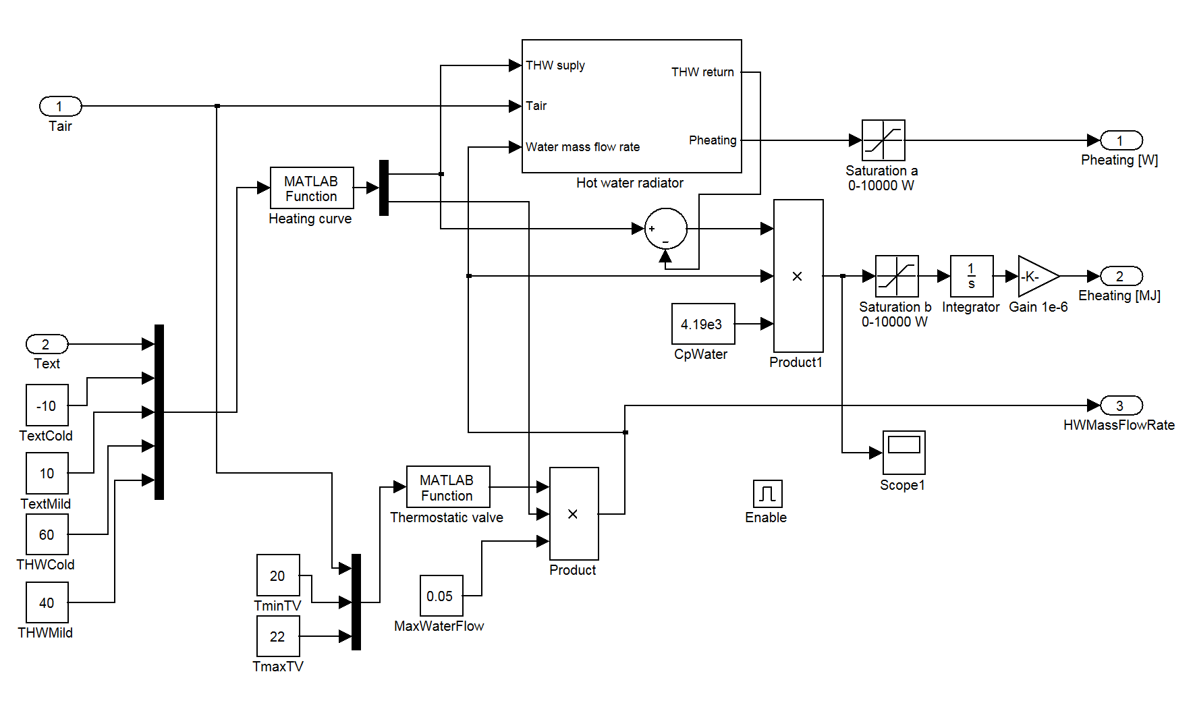

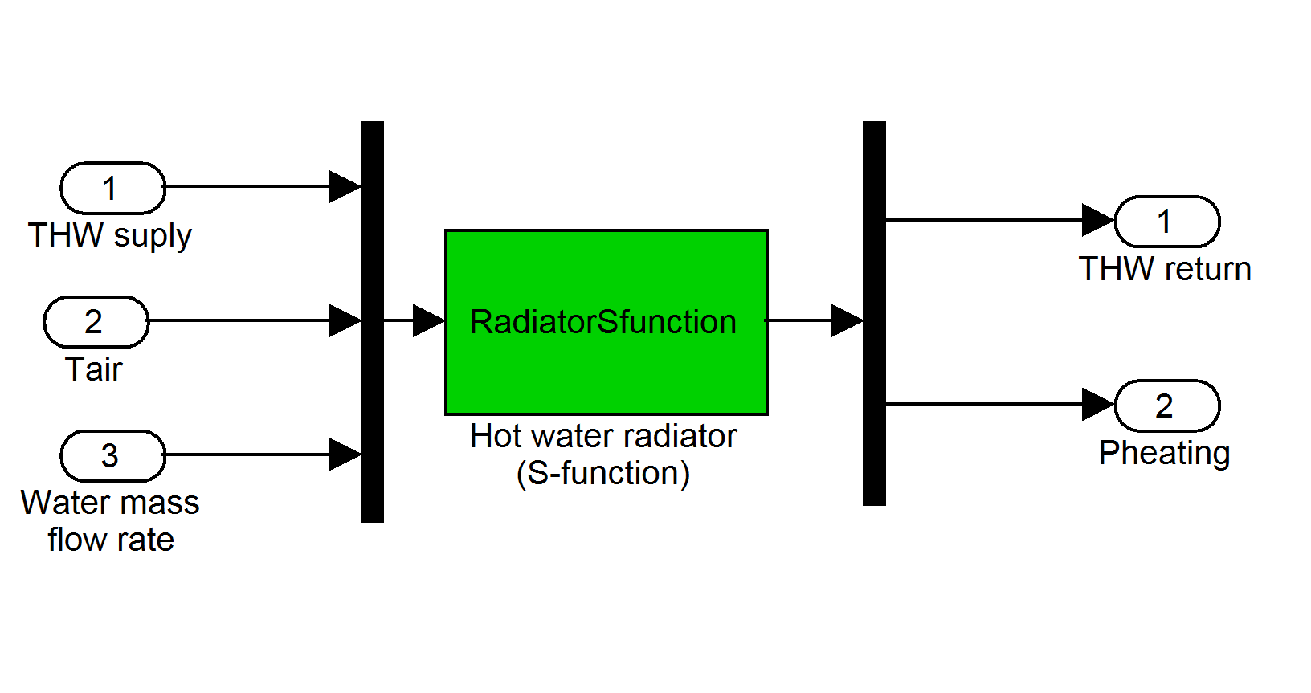

Matlab functions

The Matlab functions corresponding to the blocks Heating curve (THotWater5) and Thermostatic valve (ThermoValve3) are listed below, along with the S-function RadiatorSfunction which represents the implementation of the differential equation system.

-----------------------------------------------------------------------------

% function y=THotWater5(u): heating curve
% u(1)=Text (outside temperature) [°C]
% u(2)=TextCold (outside temperature with maximum HW temperature [°C]
% u(3)=TextMild (outside temperature with minimum HW temperature [°C]
% u(4)=THWCold (maximum hot water temperature) [°C]
% u(5)=THWMild (minimum hot water temperature) [°C]
% y(1)=hot water temperature [°C]
% y(2)=pump on/off (1 or 0)

function y=THotWater5(u)

Text=u(1,1);
TextCold=u(2,1);
TextMild=u(3,1);
THWCold=u(4,1);
THWMild=u(5,1);

if (Text<TextCold)
y(1,1)=THWCold;
y(2,1)=1;
elseif (Text>TextMild)
y(1,1)=0; % arbitrary temperature
y(2,1)=0;
else
y(1,1)=THWCold-(THWCold-THWMild)*(Text-TextCold)/(TextMild-TextCold);
y(2,1)=1;
end

-----------------------------------------------------------------------------

% function y=ThermoValve3(u): simplified (linearized) thermostatic valve
% u(1)=Tair [°C]
% u(2)=TminTV (temperature for full opening) [°C]
% u(3)=TmaxTV (temperature for full closing) [°C]
% y=opening fraction (0 to 1, 1 = completely open)

function y=ThermoValve3(u)

Tair=u(1,1);
TminTV=u(2,1);
TmaxTV=u(3,1);

if (Tair<TminTV)
y=1; % completely open
elseif (Tair>TmaxTV)
y=0; % completely closed
else
y=(TmaxTV-Tair)/(TmaxTV-TminTV);
end

-----------------------------------------------------------------------------

function [sys,x0,str,ts] = RadiatorSfunction(t,x,u,flag,mw,mm,Cpm,h,k)
% Radiator model to be used as a Simulink S-function, level 1
% parameters:
% t, x, u, flag = standard arguments of a s-function
% mw = total mass of water in radiator [kg]
% mm = total mass of radiator metallic part [kg]
% Cpm = specific heat of metal [J/kg K]
% h = h coefficient of radiator ([W/K] if k = 1)
% k = exponent coefficient of radiator
%

switch flag,

case 0, % initialization
% call simsizes for a sizes structure, fill it in and convert it back
% to a sizes array
sizes=simsizes;
sizes.NumContStates = 4;
sizes.NumDiscStates = 0;
sizes.NumOutputs = 2;
sizes.NumInputs = 3;
sizes.DirFeedthrough = 1;
sizes.NumSampleTimes = 0;
sys=simsizes(sizes);

% set the initial conditions
x0=[20,20,20,20]; % all radiator segment temperatures [°C]

% str is always an empty matrix
str=[];

% initialize the array of sample times
ts=[];

case 1, % derivatives
Cpw=4190; % specific heat of water [J/kg K]
C=0.25*(mw*Cpw+mm*Cpm); % water+metal thermal capacity of one section [J/K]
Th=u(1); % hot water supply temperature [°C]
Ta=u(2); % room ambient temperature [°C]
mp=u(3); % mass flow rate [kg/s]
sys=zeros(4,1);
dT1=x(1)-Ta;
dT2=x(2)-Ta;
dT3=x(3)-Ta;
dT4=x(4)-Ta;
sys(1)=((Th-x(1))*mp*Cpw-0.25*h*pabs(dT1,k))/C;
sys(2)=((x(1)-x(2))*mp*Cpw-0.25*h*pabs(dT2,k))/C;
sys(3)=((x(2)-x(3))*mp*Cpw-0.25*h*pabs(dT3,k))/C;
sys(4)=((x(3)-x(4))*mp*Cpw-0.25*h*pabs(dT4,k))/C;

case 2, % update
sys=[]; % do nothing

case 3, % outputs
Ta=u(2);
sys=zeros(2,1);
sys(1)=x(4); % return hot water temperature [°C]
dT1=x(1)-Ta;
dT2=x(2)-Ta;
dT3=x(3)-Ta;
dT4=x(4)-Ta;
sys(2)=0.25*h*(pabs(dT1,k)+pabs(dT2,k)+pabs(dT3,k)+pabs(dT4,k)); % Pheating [W]

case 4, % get time of next variable hit
sys=[]; % do nothing

case 9, % terminate
sys=[]; % do nothing

otherwise % unexpected flag value
error(['Unhandled flag = ',num2str(flag)]);

end

function p=pabs(x,k)
% pabs(x,k) = |x|^k * sign(x)
if (x>0), p=x^k;
elseif (x<0), p=-(-x)^k;
else p=0; end

C. Hot water floor heating, controlled by a "heating curve" and a thermostatic valve

The hot water floor heating system is handled in a very similar way as a hot water radiator system. Therefore, only the main differences will be described in the present report.

Physical model of the floor heating system

The floor heating system is modelled in a rather similar way than a hot water radiator. The floor heating piping is divided into segments, which are supposed to be in series for the water flow. On the contrary of the hot water model, we cannot suppose that the part of the system connected to the inside air (i.e. the scrub in which the piping is included) has the same temperature as the hot water. Therefore, for each segment #i there are two state variables: the hot water temperature T_{w,i}, and the (scrub) concrete temperature T_{c,i}.

Moreover, the hypotheses below are considered:
- An immediate complete mixing of hot water when flowing from segment #i to segement #i+1;
- A simplified linear relationship for the power transmitted from the heated scrub to the ambient air (instead of the relationship P = h (T_{segment} - T_{a})^{k}), represented by an equivalent conductance g_{ca};
- A conductive connection g_{wc} between the hot water and the concrete part of a given segment;
- A conductive connection g_{ws} between the hot water and the concrete slab located under the piping.

The heat balance for segment #i is expressed by the two differential equations:

C_{w} · dT_{w,i}/dt = (T_{w,i-1} - T_{w,i}) · mp · C_{pw} - (T_{w,i} - T_{c,i}) · g_{wc} - (T_{wi}-T_{s}) · g_{ws} (water, i = 1,...,n)

C_{c} · dT_{c,i}/dt = (T_{w,i} - T_{c,i}) · g_{wc} - (T_{a} - T_{c,i}) · g_{ca} (concrete, i = 1,...,n)

with: C_{w} = m_{w} · C_{pw} = thermal capacitance of water in one segment [J/K]
C_{c} = m_{c} · C_{pc} = thermal capacitance of concrete scrub of one segment [J/K]
m_{w} = water mass in one segment [kg]
C_{pw} = specific heat of water [J/kg K]
m_{c} = concrete scrub mass of one segment [kg]
C_{pc} = specific heat of concrete [J/kg K]
T_{w,i} = water temperature of segment #i [K]
T_{c,i} = concrete scrub temperature of segment #i [K]
T_{a} = ambient temperature [K]
T_{s} = slab (under scrub) temperature [K]
g_{wc} = equivalent conductance between water and concrete scrub for one segment [W/K]
g_{ws} = equivalent conductance between water and slab for one segment [W/K]
g_{ca} = equivalent conductance between concrete and ambient air for one segment [W/K]
n = number of segments

If the input hot water temperature T₀, the ambient temperature T_{a}, the slab temperature T_{s} and the water mass flow rate mp are given (external excitation vector), we have then a differential equation system with 2 · n equations and 2 · n state variables (the T_{w,i} and T_{w,c}).

Like for the hot water radiator, this equation system has been implemented using a S-function, considering 4 segments (see listing below).

Physical model of the control system

The physical model of the control system is the same as the one used for hot water radiators: a "heating curve" model is used for the hot water supply (but with different values of the hot water temperature: a floor heating system needs a much lower temperature than a radiator), and a thermostatic valve is used for controlling the individual room floor heatings. In the case of the Adhoco controller, the same as for the hot water radiator applies: the "heating curve" algorithm remains and the Adhoco controller controls only the valve of the individual floor heating.

Simulink diagram

In the block diagram, only the call to the S-function is different from the corresponding block in the hot water radiator model.
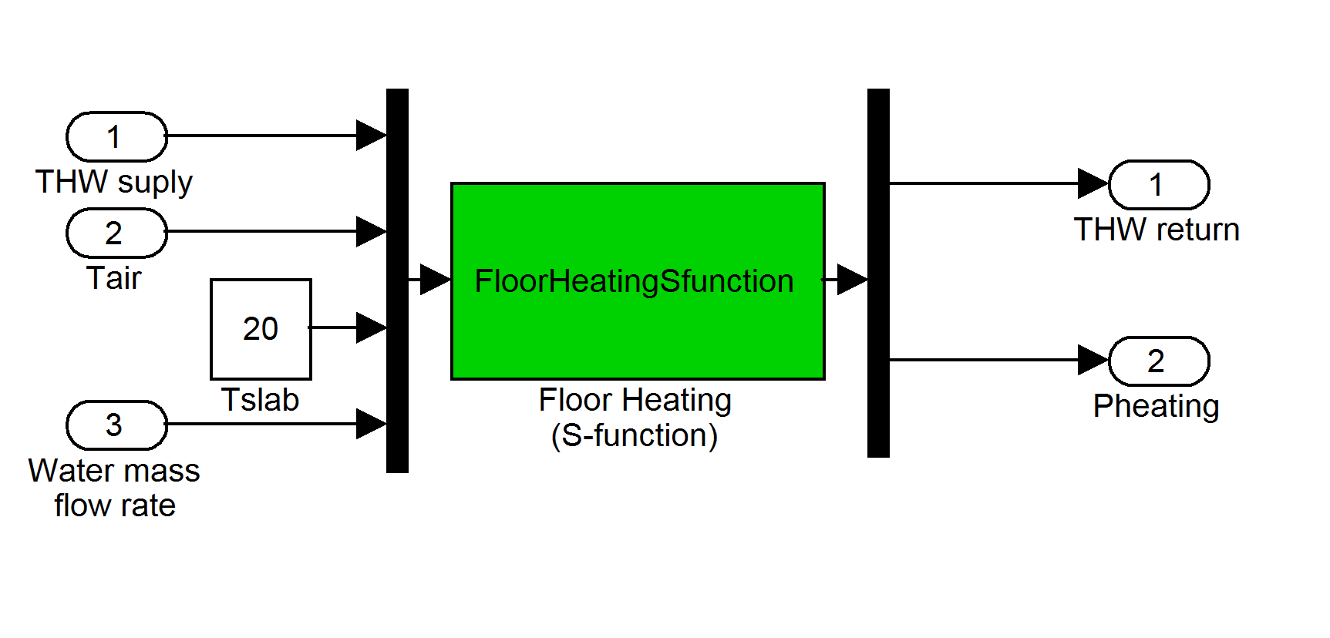

Matlab functions

The Matlab functions corresponding to the blocks Heating curve (THotWater5) and Thermostatic valve (ThermoValve3) are the same as those used for the hot water radiator. Only the S-function FloorHeatingSfunction, which represents the implementation of the differential equation system for a floor heating, is listed below.

function [sys,x0,str,ts] = FloorHeatingSfunction(t,x,u,flag,mw,mc,gwc,gws,gca)
% Floor heating model to be used as a Simulink S-function, level 1
% parameters:
% t, x, u, flag = standard arguments of a s-function
% mw = mass of water in floor heating (whole floor) [kg]
% mc = mass of concrete above pipe (whole floor) [kg]
% gwc = equivalent conductance water - concrete (whole floor) [W/K]
% gws = equivalent conductance water pipe - slab (whole floor) [W/K]
% gca = equivalent conductance concrete - ambient (whole floor) [W/K]
% external excitations:
% u(1) = Thw (hot water inlet temperature) [°C]
% u(2) = Ta (ambiant temperature) [°C]
% u(3) = Tslab (temperature of slab below floor heating) [°C]
% u(4) = mp (mass flow rate) [kg/s]

switch flag,

case 0, % initialization
% call simsizes for a sizes structure, fill it in and convert it back
% to a sizes array
sizes=simsizes;
sizes.NumContStates = 8;
sizes.NumDiscStates = 0;
sizes.NumOutputs = 2;
sizes.NumInputs = 4;
sizes.DirFeedthrough = 1;
sizes.NumSampleTimes = 0;
sys=simsizes(sizes);

% set the initial conditions
x0=[20,20,20,20,20,20,20,20]; % all water + concrete temperatures [°C]

% str is always an empty matrix
str=[];

% initialize the array of sample times
ts=[];

case 1, % derivatives
Cpw=4190; % specific heat of water [J/kg K]
Cpc=1000; % specific heat of concrete [J/kg K]
Cw=0.25*mw*Cpw; % thermal capacity of water (one section) [J/K]
Cc=0.25*mc*Cpc; % thermal capacity of concrete (one section) [J/K]
Th=u(1); % hot water supply temperature [°C]
Ta=u(2); % room ambient temperature [°C]
Ts=u(3); % slab temperature [°C]
mp=u(4); % mass flow rate [kg/s]
sys=zeros(8,1);
sys(1)=((Th-x(1))*mp*Cpw+(x(5)-x(1))*0.25*gwc+(Ts-x(1))*0.25*gws)/Cw;
sys(2)=((x(1)-x(2))*mp*Cpw+(x(6)-x(2))*0.25*gwc+(Ts-x(2))*0.25*gws)/Cw;
sys(3)=((x(2)-x(3))*mp*Cpw+(x(7)-x(3))*0.25*gwc+(Ts-x(3))*0.25*gws)/Cw;
sys(4)=((x(3)-x(4))*mp*Cpw+(x(8)-x(4))*0.25*gwc+(Ts-x(4))*0.25*gws)/Cw;
sys(5)=((x(1)-x(5))*0.25*gwc+(Ta-x(5))*0.25*gca)/Cc;
sys(6)=((x(2)-x(6))*0.25*gwc+(Ta-x(6))*0.25*gca)/Cc;
sys(7)=((x(3)-x(7))*0.25*gwc+(Ta-x(7))*0.25*gca)/Cc;
sys(8)=((x(4)-x(8))*0.25*gwc+(Ta-x(8))*0.25*gca)/Cc;

case 2, % update
sys=[]; % do nothing

case 3, % outputs
Ta=u(2);
Ts=u(3);
sys=zeros(2,1);
sys(1)=x(4); % return hot water temperature [°C]
dT1s=x(1)-Ts;
dT2s=x(2)-Ts;
dT3s=x(3)-Ts;
dT4s=x(4)-Ts;
dT1a=x(5)-Ta;
dT2a=x(6)-Ta;
dT3a=x(7)-Ta;
dT4a=x(8)-Ta;
sys(2)=0.25*gws*(dT1s+dT2s+dT3s+dT4s)+0.25*gca*(dT1a+dT2a+dT3a+dT4a); % Pheating [W]

case 4, % get time of next variable hit
sys=[]; % do nothing

case 9, % terminate
sys=[]; % do nothing

otherwise % unexpected flag value
error(['Unhandled flag = ',num2str(flag)]);

end

3.2 Simulation variants

The simulation study has been done on an office room. The room characteristics correspond to the typical rooms of the SIMBAD software. The variants below have been simulated.

Case # | Room orientation and type | Solar shading | Heating system
1 | South, heavy building | Venetian blinds | Convective heating
2 | West, heavy building | Venetian blinds | Convective heating
3 | North, heavy building | Venetian blinds | Convective heating
4 | South, light building | Venetian blinds | Convective heating
5 | West, light building | Venetian blinds | Convective heating
6 | North, light building | Venetian blinds | Convective heating
7 | South, heavy building | Venetian blinds | Water radiator
8 | South, light building | Venetian blinds | Water radiator
9 | South, heavy building | Venetian blinds | Floor heating
10 | South, light building | Venetian blinds | Floor heating
11 | South, heavy building | Fabric blinds | Convective heating
12 | South, light building | Fabric blinds | Convective heating

For each considered case, 3 control variants were simulated:
- Manual control, with a basic model of human behaviour;
- Simple commercial controller using the cutoff solar angle algorithm and daylight responsive electric lighting;
- Adhoco controller.

This choice of variants allows to compare the control algorithms with various situations and conditions (room orientation, building thermal mass, type of solar shadings, type of heating system). For each case, the manual control simulating a basic human behaviour was planned to be considered as the base case.

3.3 Simulation results

For the 12 cases with 3 controller variants, a simulation over one whole year was carried out. The table below gives the annual energy consumptions for the room (floor area 25 m²): E_{light} is the energy consumed for the electric lighting, and E_{heat} the energy for heating. It has to be noted that programming errors in the simulation code have invalidated the following results (the numbers are not reported in the table):
- the electric lighting energy E_{light} for the base variant (a);
- the heating energy E_{heat} for the simple commercial controller (b);
- the heating energy E_{heat} for the case #2 with Adhoco controller (c).

Case # | Room orientation and type | Solar shading | Heating system | Control variant | E_{light} [MJ] | E_{heat} [MJ]
1 | South, heavy building | Venetian blinds | Convective heating | (a) | - | 4969
 |  |  |  | (b) | 352 | -
 |  |  |  | (c) | 232 | 3759
2 | West, heavy building | Venetian blinds | Convective heating | (a) | - | 6353
 |  |  |  | (b) | 371 | -
 |  |  |  | (c) | 232 | -
3 | North, heavy building | Venetian blinds | Convective heating | (a) | - | 7609
 |  |  |  | (b) | 402 | -
 |  |  |  | (c) | 232 | 5613
4 | South, light building | Venetian blinds | Convective heating | (a) | - | 5746
 |  |  |  | (b) | 352 | -
 |  |  |  | (c) | 232 | 3399
5 | West, light building | Venetian blinds | Convective heating | (a) | - | 6774
 |  |  |  | (b) | 371 | -
 |  |  |  | (c) | 232 | 3884
6 | North, light building | Venetian blinds | Convective heating | (a) | - | 7783
 |  |  |  | (b) | 402 | -
 |  |  |  | (c) | 232 | 4411
7 | South, heavy building | Venetian blinds | Water radiator | (a) | - | 5451
 |  |  |  | (b) | 352 | -
 |  |  |  | (c) | 232 | 3748
8 | South, light building | Venetian blinds | Water radiator | (a) | - | 6096
 |  |  |  | (b) | 352 | -
 |  |  |  | (c) | 232 | 3193
9 | South, heavy building | Venetian blinds | Floor heating | (a) | - | 5472
 |  |  |  | (b) | 352 | -
 |  |  |  | (c) | 232 | 4375
10 | South, light building | Venetian blinds | Floor heating | (a) | - | 5879
 |  |  |  | (b) | 352 | -
 |  |  |  | (c) | 232 | 3857
11 | South, heavy building | Fabric blinds | Convective heating | (a) | - | 4969
 |  |  |  | (b) | 428 | -
 |  |  |  | (c) | 232 | 3596
12 | South, light building | Fabric blinds | Convective heating | (a) | - | 5746
 |  |  |  | (b) | 428 | -
 |  |  |  | (c) | 233 | 3243

Due to the missing values, a complete comparison cannot be done, but we can say that the Adhoco controller allows a lighting energy saving between 35% and 45% when compared to a conventional commercial controller, and a heating energy saving between 20 % and 30 % for heavy buildings and between 35 % and 45 % for light buildings, when compared to a manual use of the heating equipment (fixed setpoint).

4. Experimental tests in a one-family house near Winterthur

The installation has been done in a 3-rooms flat with two inhabitants. The flat is oriented towards South for the living room and towards North for the bed room and office room.

The components installed are list below. See part 6 for a description of the products.

Living room | Office room | Bed room
2 presence sensor (P1) | 1 presence sensor (P1) | 1 presence sensor (P1)
1 switch lamp (S1) | 1 switch lamp (S1) | 1 switch lamp (S1)
1 dimmer lamp (S2) | 1 venetian blind (B1)
1 venetian blind on balcony (B1) | 1 heating valve (V1)
1 heating valve (V1) | 1 temperature sensor (C1)
1 temperature sensor (C1)
1 central control unit (H1)

In addition, a mini-weather station (M1) has been installed on the balcony facing South.
The system has been tested during 6 months (February – July 2007) and questionnaires have been filled out by the two occupants every month. The questionnaire has been taken from the one developed in the AdControl project mentioned before. It has slightly been adapted to the specific need of the project.



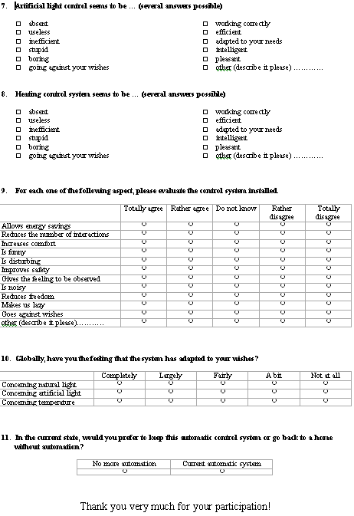

Overall result is that user A was positive about the system but user B was a bit more negative.

Globally both users were finding the lights inside their home as “normal”. They were rarely disturbed by artificial lighting but “sometimes” disturbed by natural light. The explanation of this is different for each user. User A is complaining about occasional reflections on TV, and user B is complaining about glare from Window.
It could be that the control of blinds have not managed to adapt to the user B specific needs, even if he feels some adaptation from it. It considers the blind control as “intelligent” but also “boring”.

Thermal comfort has been assessed always “slightly warm” by User A and always “neutral” by User B. It is a good result, but this also shows that if thermal needs of different users is different the system has of course no way to adapt to each of them. In this installation the control system has found a good balance between the two users. Both users are considering the heating system as “working correctly” (from February to April). The good temperature has also been kept in summer, probably due to the efficient blind control doing sun protection during absence. User B thinks that the system is allowing energy savings, whereas the User A not.

Globally, User B has the feeling to be observed and considers the system as rather noisy. He had not felt the adaptation during the first month, but then had the feeling that the system adapts to his needs a bit. But all in all, he hesitates to keep the automation system.
User A is more enthusiastic; he feels the adaptation and would like to keep the automation system.

These results have shown again that adaptation to user specific needs is a “must” to have the acceptance of automation system. For the Adhoco system, it has shown that some improvements are still necessary in the adaptation algorithm, especially for blinds. A new version of this algorithm has been elaborated but has unfortunately not been re-tested in the frame of this project.

5. Experimental setup at LESO Building

5.1 Setup

Although no long term measurements were carried out at the LESO Building, the experimental setup was completed in two office rooms. Using two office rooms for the experimental tests would have allowed to exchange regularly a conventional system (manual control) and the Adhoco control system. Operational tests showed that the system operates correctly (except for the frequent crashes and the unreliability, due to the software problems that have been already discussed above). Unfortunately, only subjective evaluation of the system were available.

Each room is equipped with the following sensors and actuators, connected to an EIB building bus:
- air temperature [°C]
- inside illuminance on the workplane [lux]
- window opening (0 or 1)
- up/down command buttons for the venetian blinds (two pairs of buttons, one for the normal window and one for the anidolic window)
- on/off and dimming buttons for the electric lighting
- actuators for the venetian blinds
- actuator for the electric lighting
- electricity consumption meters (separate for heating and appliances)

The EIB bus is connected to a computer on which an EIB server software logs all the EIB telegrams and allows the commands to be taken from another client computer on which the control algorithms are implemented. In our case, that latter computer was not needed, since the comtrol algorithms were implemented on the central unit (aHeart) of the Adhoco control system.

It has been decided at the beginning of the project that we would not test the functionality of the wireless sensors (which have been thoroughsly tested at the Adhoco premises in Winterthur), but only the functionality of the control algorithm and the aHeart central unit. Therefore, the experimental setup could use the (already existing) EIB sensors and actuators to make the setup simpler.

5.2 Connexion to an EIB building bus

The particular situation of the LESO Building has lead to the requirement of a module to link the aHeart central unit to a EIB bus, in order to allow on the one hand using the sensors connected to the EIB bus, on the other hand to give commands to the actuators also connected to the EIB bus. It was also acknowledged that this module would represent a very useful element in the case of buildings already partially equipped with an EIB bus, and would therefore represent a commercial advantage for the Adhoco controller module set.

This module consists of a commercially available KNX/IP gateway (the N148 from Siemens) in combination with a Java driver written by Adhoco. It is used to send commands to EIB actuators and also to monitor group addresses to detect environmental changes (such as presence, illuminances, …).
The Adhoco controller uses the Java driver to send IP request/telegrams to the gateway, and this one translates these IP packets in KNX telegrams. On the opposite, the KNX/IP gateway listens to every packet on the KNX side and translate them in IP multicast telegrams. The Java driver fetches all IP multicast packets coming and forward them to the Adhoco controller.

6. Commercially available elements of the Adhoco system

Here is described the different Adhoco components used in the project. More information may be obtained on the Adhoco website: www.adhoco.com.

H1

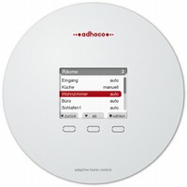

This component has the size of a CD and is the heart of the Adhoco system. It receives over a wireless connection all necessary information from the sensors and the user interactions, analyses the living environment, and issues commands to maximize comfort, security and energy savings. The unit can be operated with three sensor buttons - just like a mobile phone.

P1

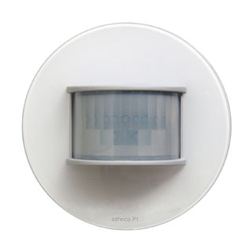

P1 is a combination of a presence detector (infrared based) and an indoor illuminance sensor. It sends wirelessly the collected information to H1. It works with 2 AAA batteries.

C1

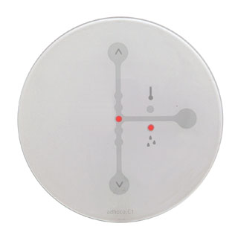

C1 has the same size as P1 and also works on batteries. It measures temperature and humidity and also let the user to modify the setpoints for these two values.

M1
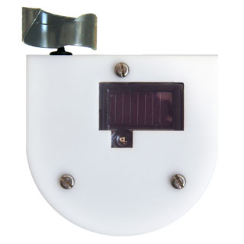

M1 is a mini-weather station. It measures illuminance, temperature, humidity and windspeed. It communicates wirelessly with H1. It is powered by solar cells.

S1/S2

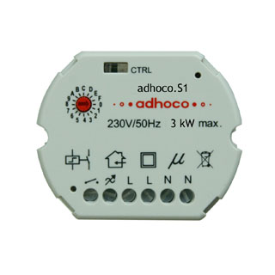
These components are installed behind the standard buttons for switching lamps. They communicate wirelessly with H1, informing about user actions on lamps and receive switching commands from the central control unit. S1 can switch on and off up to 16 A current and S2 can dim lamps from 0% to 100% of full power.

B1

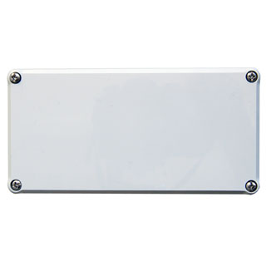
B1 is an advanced electric blind motor controller. It can control fabric blinds, venetian blinds and textile blinds. It communicates wirelessly with H1, informing about user actions on blinds and receives moving commands from the central control unit.

V1

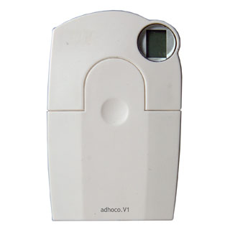

V1 is a heating valve that is compatible with all different kinds of water radiators. It is powered by two AA batteries and wirelessly receives command from H1 to open/close the valve from 0 to 100%.

7. Conclusion

